William Mackay
MTH 337, Professor Adam Cunningham

Weekly Report 05
Introduction
The butterfly effect is a phenomenon that occurs in mathematical models which is characterized by large changes in behavior resulting from small variations in initial conditions. This effect was discovered by Edward Lorenz when he was attempting to model the weather. He discovered that changes in the initial conditions to his weather model resulting from rounding error caused the model to diverge completely after some time [1]. Understanding how a model reacts to changes in its initial conditions when different parameters are used is important in ensuring that the model behaves properly. In order to see whether the mayfly population model discussed in Weekly Report 03 exhibits this behavior, a Python script was written to test the model using several different values for the growth rate b.
Approach
In order to see if the model exhibited the butterfly effect at different values of b, the model was run twice at each b value. Each instance of the model had slightly different initial conditions. The separation between both populations at each time was calculated and plotted. Two primary functions were used in this Python script. The first was separation(), which ran two simultaneous models for a given length of time with two given initial conditions and then stored the separation between the models at each time step. The second was linear_fit(), which took two arrays and used linear least squares to generate the coefficients α and β of the best fit line for that set of data. Because the separation between the two instances of the mayfly model grew or shrunk logarithmically with time, semilogy was used to plot the data as opposed to the normal plot command. This also altered the approach used to generate the best fit line. Because of the logarithmic relationship, the time and separation arrays could not be fed directly into the linear_fit function. Instead, time and the natural logarithm of the separation were fed into the linear_fit function. This resulted in linear behavior when the data and best fit lines were plotted using semilogy.
Results
When these two functions were applied to four different values of b (1.5, 4, 2.5, and 3.2), the plots in figures 1, 2, 3, and 4 were obtained.
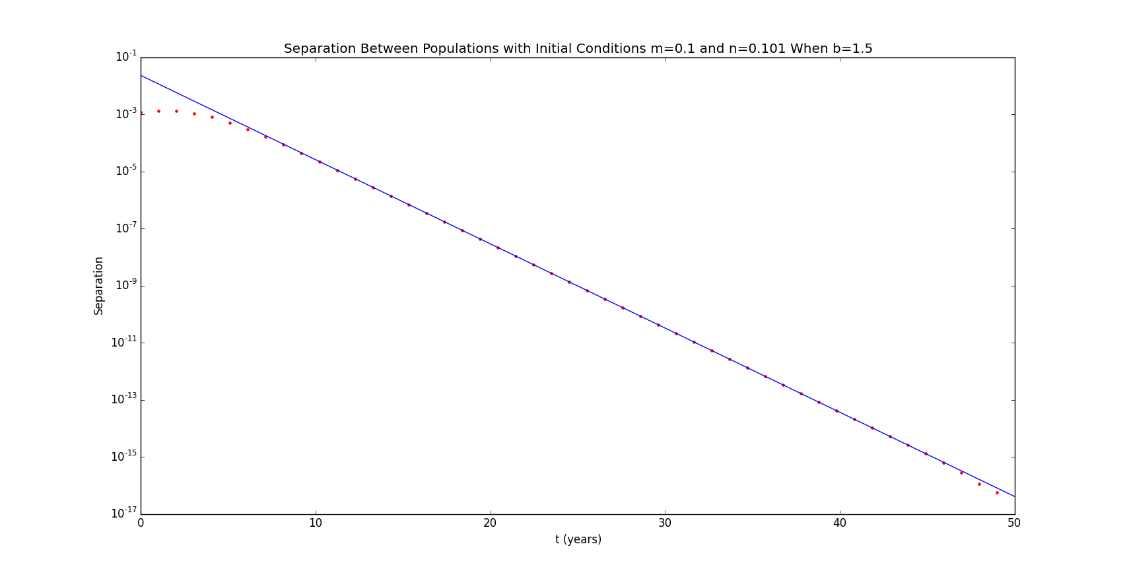Figure 1
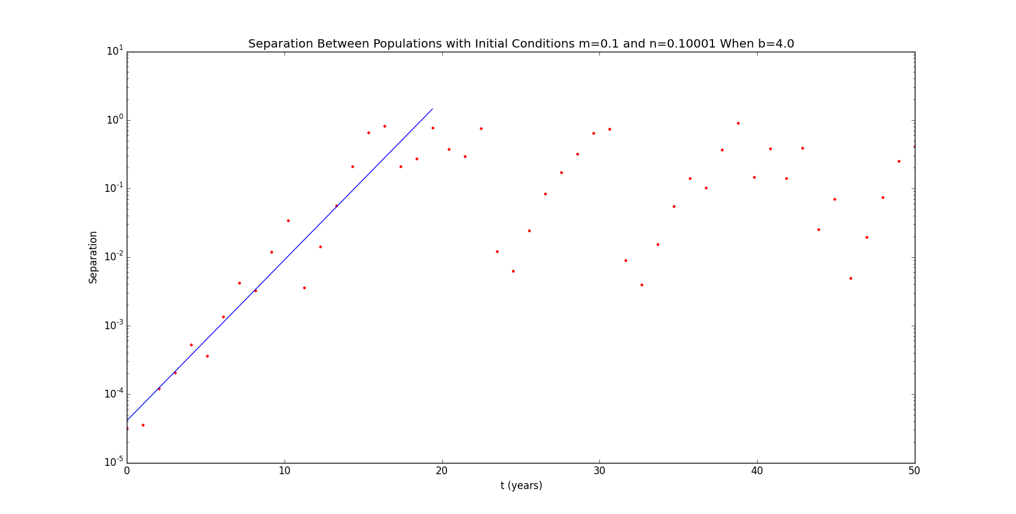Figure 2
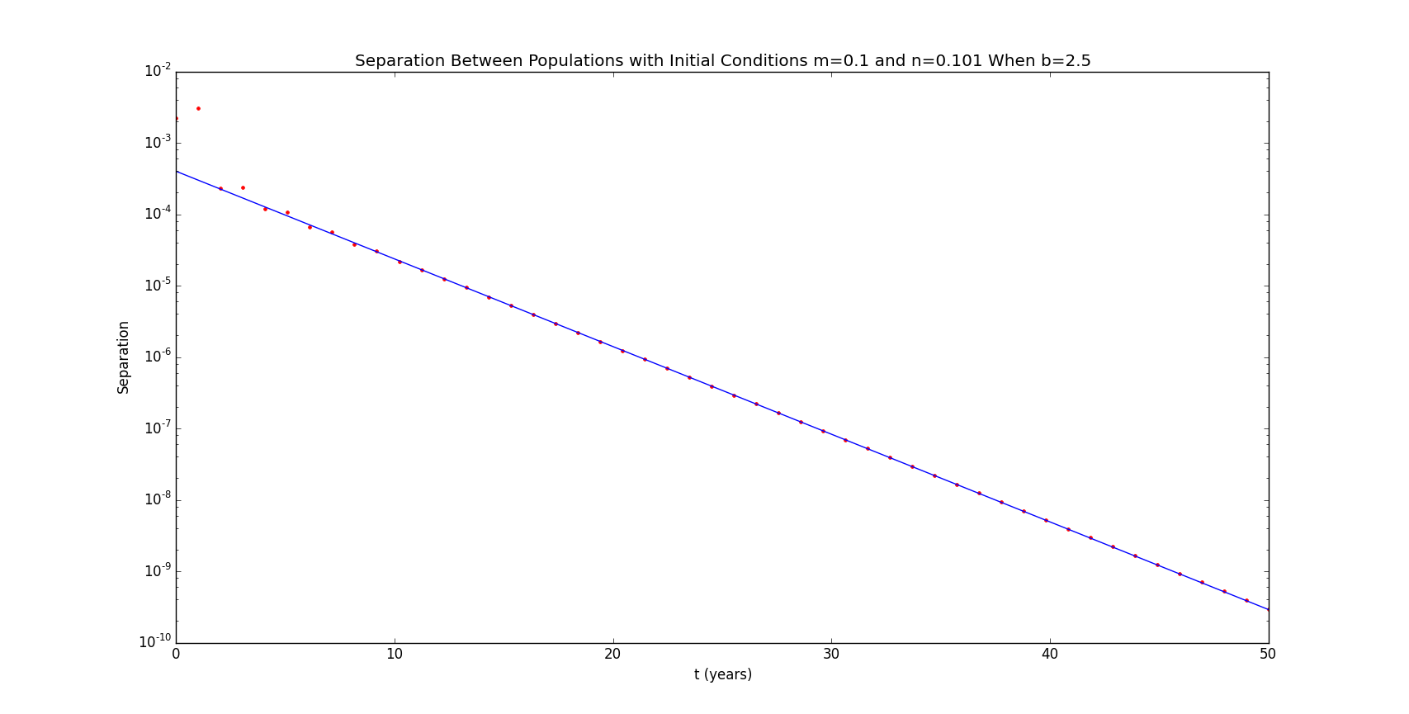Figure 3
The coefficients α and β of the best fit line for the separation at each time step were calculated for each value of b. When b was 1.5, α was -3.787 and β was -0.679. When b was 4.0, α was -10.096 and β was 0.540. When b was 2.5, α was -7.827 and β was -0.283. When b was 3.2, α was 3.806 and β was -0.896. Note that because these coefficients were calculated using the natural logarithm of the separation, the e raised to the value of the best fit line at each time step was plotted.
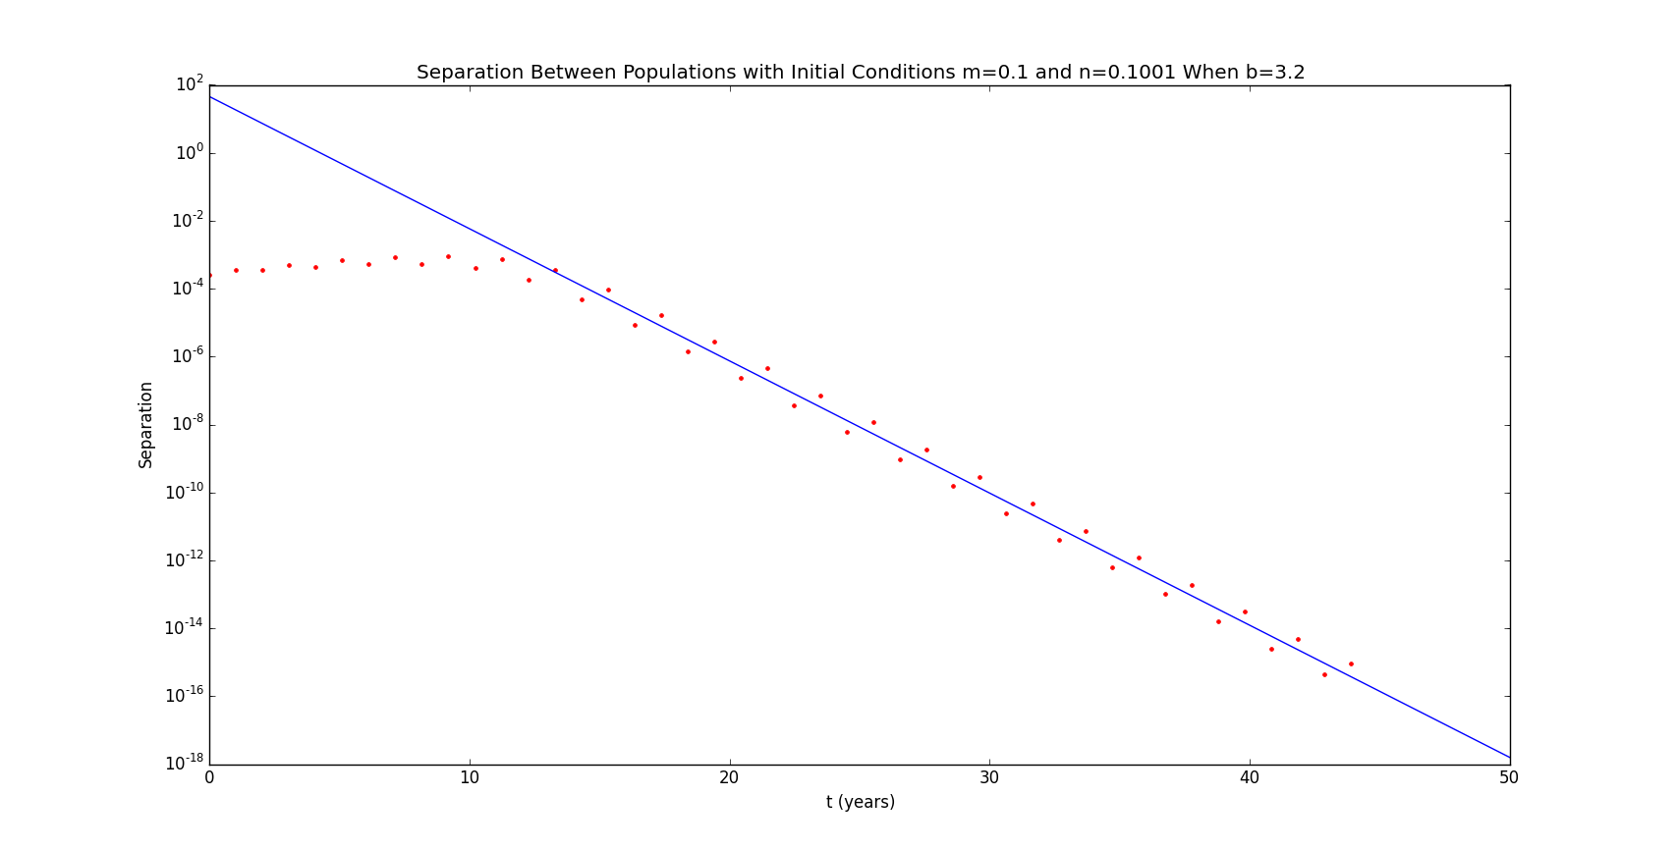Figure 4
Conclusion
Of the four b values tested, only one caused the butterfly effect to occur in the model. For the b values 1.5, 2.5, and 3.2, both instances of the model eventually converged so that the separation between the two models was 0. When b was 4.0, the model completely diverged, reaching the maximum separation of 1.0 within 20 time steps even when the initial conditions only differed by 0.00001. After the initial growth in separation, the separation appeared to oscillate about a value of approximately 0.06. Despite the fact that the model converged for a b value of 3.2, the model took significantly longer to do so. The separation only began to decrease after about 13 time steps. When b was 2.5, the model began to converge quickly, but β was less negative for this b value than it was for 1.5 (-0.283 vs. -0.679), even with the same initial separation. β, the growth rate of the best fit line, is an indication of the speed of convergence between the two instances of the model. A more negative value of β means a more negative slope, and therefore faster convergence. A positive β value indicates that the two instances of the model are diverging. These observations indicate that the model becomes less stable as b increases. Even though the model only begins to diverge for large values of b, the speed of convergence decreases with increasing values of b.
Python Code
#William Mackay
#MTH 337- Assignment 5

from pylab import *

def linear_fit(x,y):
alpha=mean(y)-mean(x)*((mean(x*y)-mean(x)*mean(y))/(mean(x**2)-mean(x)**2))
beta=(mean(x*y)-mean(x)*mean(y))/(mean(x**2)-mean(x)**2)
coeffs=[alpha,beta]
return coeffs

def separation(m,n,b,t_max):
s=empty(t_max)
for i in xrange(t_max):
m=b*(1-m)*m
n=b*(1-n)*n
s[i]=abs(m-n)
return s

m=0.1
n1,n2,n3,n4=0.101,0.10001,0.101,0.1001
b1,b2,b3,b4=1.5,4.0,2.75,3.2
t_max=50
t=linspace(0,t_max,t_max)

s1=separation(m,n1,b1,t_max)
s2=separation(m,n2,b2,t_max)
s3=separation(m,n3,b3,t_max)
s4=separation(m,n4,b4,t_max)

figure(1)
semilogy(t,s1,'r.')
coeffs1=linear_fit(t[9:40],log(s1[9:40]))
bestfit1=coeffs1[1]*t+coeffs1[0]
semilogy(t,exp(bestfit1))
title('Separation Between Populations with Initial Conditions m=0.1 and n=0.101 When b=1.5')
xlabel('t (years)')
ylabel('Separation')

figure(2)
semilogy(t,s2,'r.')
coeffs2=linear_fit(t[0:20],log(s2[0:20]))
bestfit2=coeffs2[1]*t+coeffs2[0]
semilogy(t[0:20],exp(bestfit2[0:20]))
title('Separation Between Populations with Initial Conditions m=0.1 and n=0.10001 When b=4.0')
xlabel('t (years)')
ylabel('Separation')

figure(3)
semilogy(t,s3,'r.')
coeffs3=linear_fit(t[5:40],log(s3[5:40]))
bestfit3=coeffs3[1]*t+coeffs3[0]
semilogy(t,exp(bestfit3))
title('Separation Between Populations with Initial Conditions m=0.1 and n=0.101 When b=2.5')
xlabel('t (years)')
ylabel('Separation')

figure(4)
semilogy(t,s4,'r.')
coeffs4=linear_fit(t[15:40],log(s4[15:40]))
bestfit4=coeffs4[1]*t+coeffs4[0]
semilogy(t,exp(bestfit4))
title('Separation Between Populations with Initial Conditions m=0.1 and n=0.1001 When b=3.2')
xlabel('t (years)')
ylabel('Separation')

print coeffs1
print coeffs2
print coeffs3
print coeffs4

show()

References
[1] Lienhard, J. (n.d.). No. 652: The Butterfly Effect. Retrieved October 9, 2015, from http://www.uh.edu/engines/epi652.htm

